Sub RevComplement()
'
'

Set oRng = Selection.Range
RevDNA = StrReverse(oRng)
RevDNA = Replace(RevDNA, "A", "%")
RevDNA = Replace(RevDNA, "T", "#")
RevDNA = Replace(RevDNA, "%", "T")
RevDNA = Replace(RevDNA, "#", "A")

RevDNA = Replace(RevDNA, "a", "%")
RevDNA = Replace(RevDNA, "t", "#")
RevDNA = Replace(RevDNA, "%", "t")
RevDNA = Replace(RevDNA, "#", "a")

RevDNA = Replace(RevDNA, "C", "%")
RevDNA = Replace(RevDNA, "G", "#")
RevDNA = Replace(RevDNA, "%", "G")
RevDNA = Replace(RevDNA, "#", "C")

RevDNA = Replace(RevDNA, "c", "%")
RevDNA = Replace(RevDNA, "g", "#")
RevDNA = Replace(RevDNA, "%", "g")
RevDNA = Replace(RevDNA, "#", "c")

' Writes RevDNA back into the word document
Selection.TypeText (RevDNA)
End Sub

Instructions for inserting script into a word macro.

- Open the macros interface
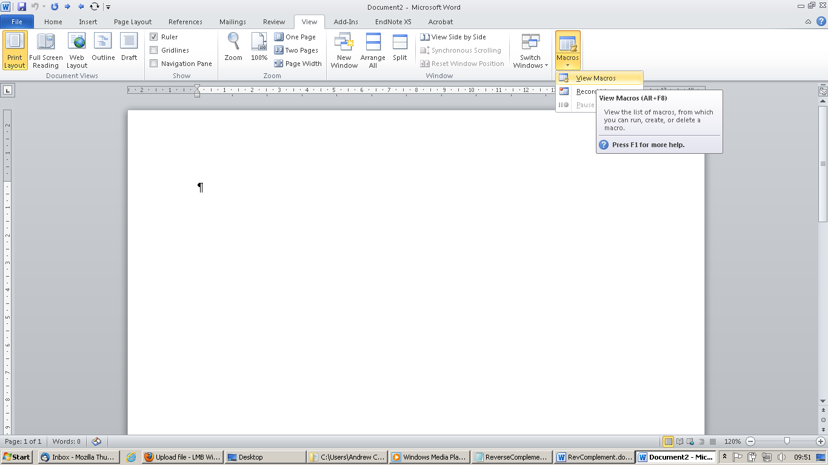

- Press Create to make a new macro

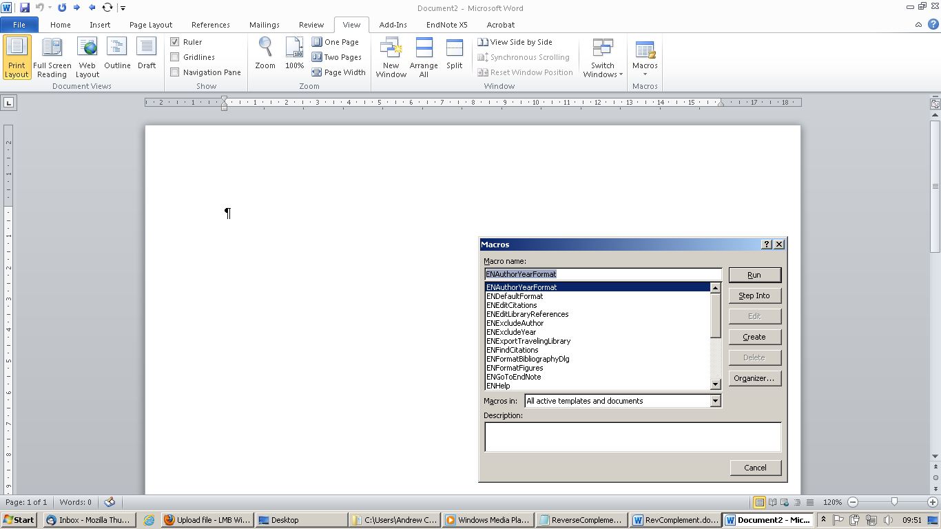
- Delete the empty macro and paste the above script into its place. Then save and close the Visual Basic editor

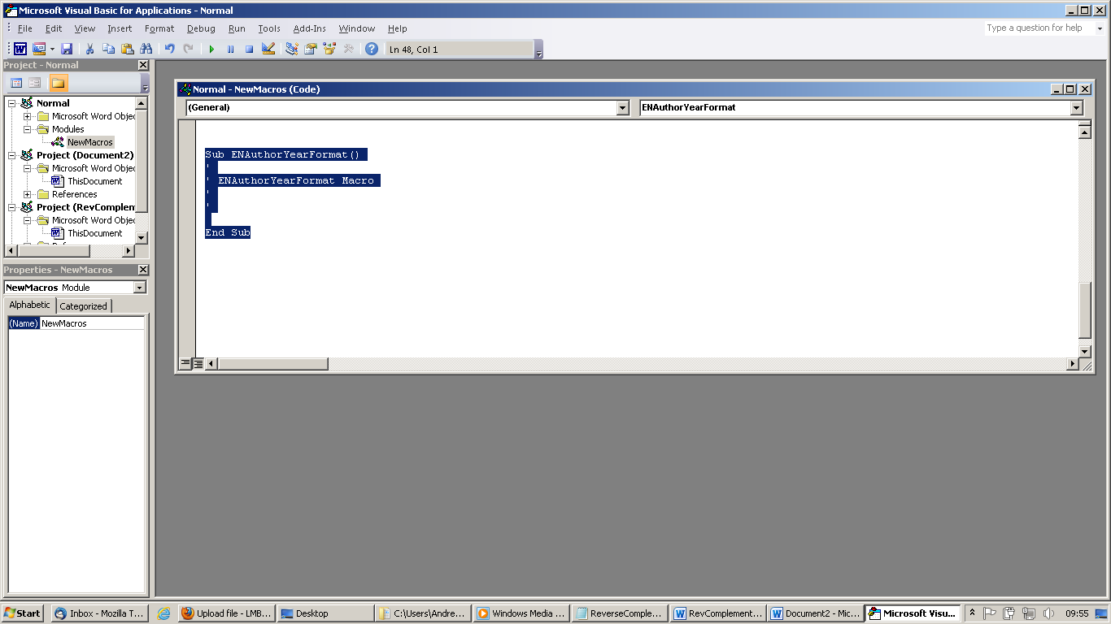

- Insert the macro onto the tool bar: Select more commands from the Customize Quick Access toolbar.

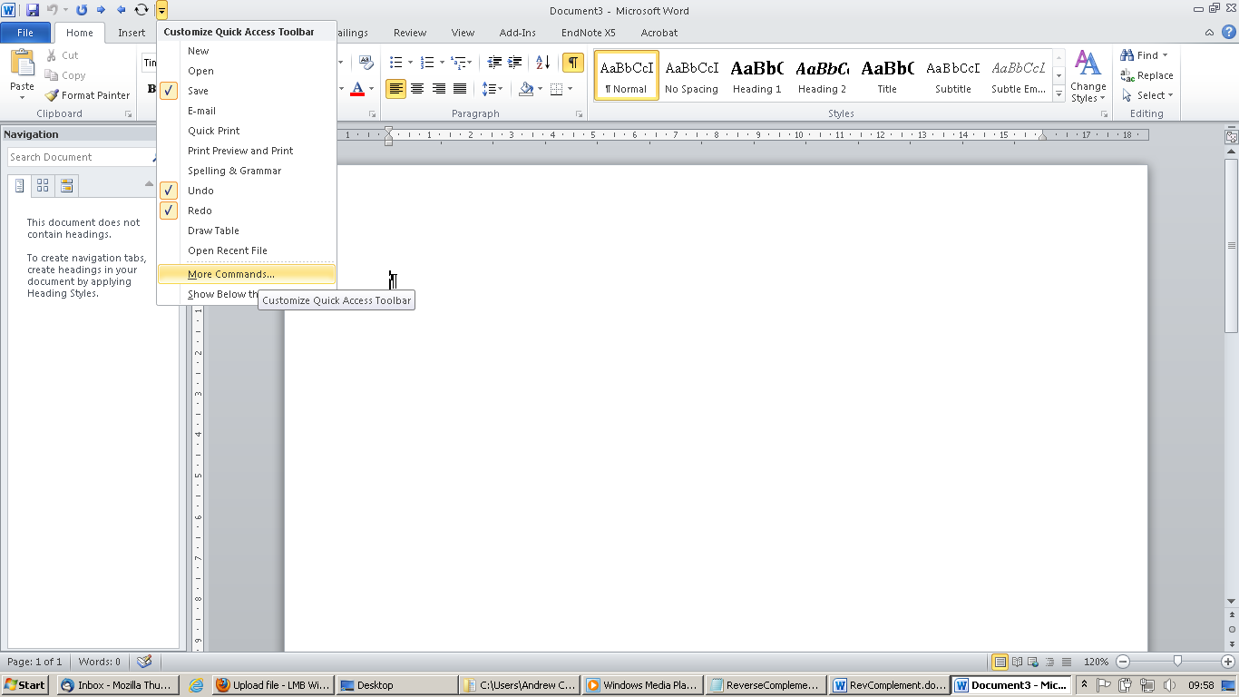
- Select “Macros” from the “Choose Commands” menu.

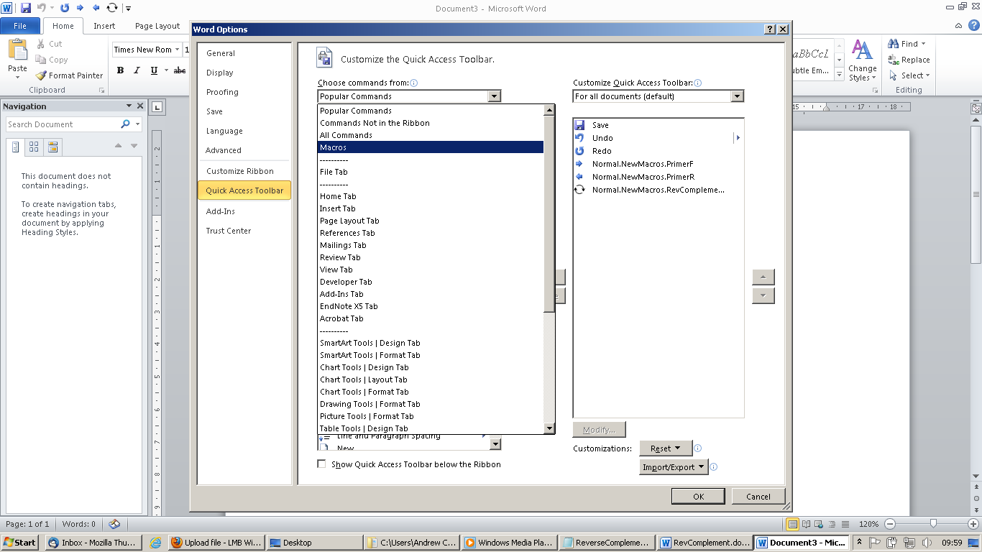

- Select the Macro you have just made, press add to move it to the toolbar list. You can then select the “Modify” button to choose a different icon.
